**Minutes of the Grateley Parish Council Meeting held on Tuesday 7th of**

**March 2023 in the Grateley Village Hall at 7.00pm.**

Present: Cllr Mr K Smith – Chair

Cllr Mr I Wingfield

Cllr Mr A Bradford

Cllr A Bettle-Shaffer

Richard Waterman – Parish Clerk

County Councillor Mr C Donnelly

Members of the Public – 4

Apologies: Cllr Mr M Horne and Borough Councillors Mr D Coole and Mrs M Flood.

**WELCOME.**

The Chair welcomed everyone to the meeting.

**DECLARATION OF INTEREST.**

Cllr Mr K Smith declared an interest in the Parling Issue in Campbell and Locke Close.

**MINUTES OF THE PREVIOUS MEETING.**

The Chairman signed the minutes (after a minor alteration of the previous meeting as a true record. Matters Arising from those minutes:

PLAY AREA – Cllr Mr I Wingfield reported that he will have three quotes for the Play Equipment within the next few weeks. Once he quotes are in, he will consult with the Play Area Committee to agree the contractor. A funding application has been submitted for £10,000. If everything runs smoothly and the grants are approved, we could be possibly looking at a July 2023 start.

The possibility of a sewer pipe close to the surface on the Locke Close Field is still being investigated.

HIGWAYS – Cllr Mr I Wingfield has reported several potholes in the Parish to Highways. There have been traffic lights on the railway bridge, but the pothole has not been repaired.

Cllr Mr A Bradfield reported that he had attended a meeting at Test Valley Borough Council to meet the head of Highways Mr Nick Adam-King. The meeting was more of an introduction rather than dealing with specific parish issues. Cllr Mr C Donnelly reported that further Parish Meetings will be held in the future.

FOOTPATHS – Cllr Mr I Wingfield reported that the footpaths are clear and walkable.

SPEEDING – A new supplier of the Flashing Speed indicator has been found and the information has been requested.

DOG BIN – It is hoped that the dog bin and moving the rubbish bin will be carried out in April 2023.

NEIGHBOURHOOD WATCH – The new Neighbourhood Watch signs are on order.

**PLANNING.**

A recent planning application for tree works has been submitted. NO OBJECTIONS.

**NEIGHBOURHOOD DEVELOPMENT PLAN.**

Mrs J Lynch reported that the next NDP Meeting is to be held on the 13th of March 2023. A recent application for funding to set up a website was successful, and a web publisher engaged. A habitat survey is to be undertaken and a Planning Consultant is to be engaged to help take the NDP forward.

**FINANCE.**

**FINANCIAL REPORT.**

**1ST April 2022 to 7th February 2023**

Opening Balance £ 22,824.16

CIL Money £ 1,818.45

Plus Precept £ 8,400.00

VAT Refund £ 928.76

**£33,971.37**

Less Expenditure

Audit £185.00

Dog Bin Emptying £205.43

Clerks Wages £3.300.00

Jubilee Expenses £791.29

NDP Expenses £73.50

Defibrillator Battery and Pads £137.45

Flashing Speed Sign Maint £517.80

Website £189.84

Village Hall Grant £1,664.00

Church Grant – 3 years £1,800.00

Office – Microsoft £154.99

Printing P/A Survey £259.00

Paint for Bus Shelter £63.85

Insurance £678.89

**£10,021.04**

Money in the bank = £23,950.33

**RESILIENCE PLAN.**

The Parish Council have not progressed with the Resilience Plan. This was discussed at length. It was agreed that making the Village Hall a Warm Hub for the vulnerable in the Parish if there is a power outage was a priority. The Clerk reported that there are still grants available from SSE to install generators etc. to make the hall self sufficient if there is a power outage.

Cllr Mr A Bradfield pointed out that there are a few electrical issues that would need to be overcome regarding the heating in the hall. Advice would need to be taken on how the heating would be isolated when the power is supplied by a generator. This was noted.

**COUNTY COUNCILLOR MR C DONNELLY.**

Cllr Mr C Donnelley reported on the following issues:

* The Lengthsman Scheme is to continue. Hampshire County Council have reviewed the criteria and the Lengthsman will now be able to undertake further jobs previously not covered by Highways Policy.
* The HCC part of the Council Tax is to increase by 4.99%.
* There is a small County Councillor Grant available to each parish to help with the celebrations for the Kings Coronation.
* Hampshire Constabulary are to get another 50 Police Officers. Community Policing will be increased to help combat rural crime.
* 97% of applications for school places received their first choice.
* HCC are undertaking a Transport Consultation available on the Hampshire County Council website.

Cllr A Bettle-Shaffer asked Cllr Mr C Donnelly if there was any up-date on the flooding issue on Wallop Road. The large puddle still forms after heavy rainfall.

Cllr Mr C Donnelly reported that he has raised this with Hampshire Highways and will raise the issue again as there has been no progress on this issue.

**PARKING IN LOCKE CLOSE AND CAMPBELL CLOSE.**

The Chair reported the following:

**Parking issues in Campbell Close.**

Several residents of Campbell Close have brought to the attention of Grateley Parish Council issues with regard to on street parking within the close.

**Background**.

Parking restrictions in the Close was introduced and managed by Test Valley Borough Council (TVBC) due to the miss use of parking. Commuters were parking in the close to avoid Network Rail parking charges at Grateley Station. It was decided by TVBC to restrict parking by introducing double yellow lines throughout, with the exception of 13 designated parking bays that are restricted to 2 hours, within 10.00 – 15.00 hrs timeframe, with no return. Failure to observe the restrictions the offender would be served with a fine. This would hopefully deter commuters from parking in the close, however, this could only be achieved by policing by TVBC and intervention by residents of the close.

In the interest of fairness, in the first instance, TVBC offered parking permits to any resident that did not have off street parking on their property, together with a Visitors permit at a cost of £15 per permit/per year. Visitor permits could be requested by the other residence at a cost of £15 per permit/per year. Since then, subsequent rises in the permit cost occurred, increasing to £25 per permit/per year.

Since the transfer of management of the parking permits to Hampshire County Council, the cost in the second year increased to £50 per permit/per year. Apparently, it is understood that there is also an issue with regard to a resident acquiring 2 permits, allowing them to park in the close whilst their customers can park in front of their property avoiding the restrictions.

Layout Plan.

Parking bays shown thus: (= 1 parking bay).



Issues arising:

1. Illegal parking restricting access for emergency vehicles, in particular Fire and Rescue Services.
2. Justification of the increase in charges for permits.
3. Not being able to park within the close, regardless of having a permit.
4. Misuse of permits.
5. Illegal parking.
6. Enforcement of parking restriction.
7. Illegal parking across driveways.

**Parking Issues in Locke Close.**

A resident of Locke Close has brought to the attention of Grateley Parish Council (GPC) issues with on street parking within the close.

Locke Close was developed on behalf of Rural Housing Trust Ltd. (RHTL) who manage the site, however, they ‘*cannot enforce parking or deal with the condition of vehicles on the road.’* With this in mind, the Resident contacted GPC.

There has been no consideration for the provision of on street parking, all parking is provided off-street within the demise of each property. With most properties having at least 2 vehicles within the family, vehicles are having to park partially on adopted footpath/verge/land and the close itself. What has also impacted on parking is the number of residents work vehicles being parked on site. Planning permission for extensions has been applied for at 17 of the 26 properties of which some has impacted on off street parking. There also appears to be an issue with vehicle repairs, as shown in the photograph’s hereafter. Whilst there is little to be done with regard to Residents repairing their vehicles on their own demise, repairs undertaken on adopted areas can be prohibited by TVBC.

Layout Plan

It has been suggested that TVBC did not adopt Locke Close, this should be clarified prior to approaching them.

The issues arising from overparking are:

1. Emergency vehicles not being able to access the close fully, in particular the Fire and Rescue Service vehicles.
2. Inconvenience to all Residents.
3. Residents being unable to park by their property.
4. Access to properties is being restricted.
5. Inconvenience for delivery vehicles.
6. Inconvenience for house removal vehicles.
7. Restrictions leading to illegal parking.
8. Environmental impact on adopted grassed areas (damage).
9. Environmental impact (visual appearance).

Photographic Evidence of the Overparking and Vehicle Repairs.

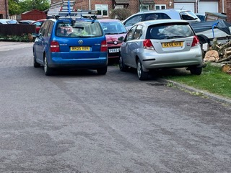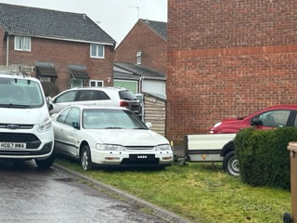

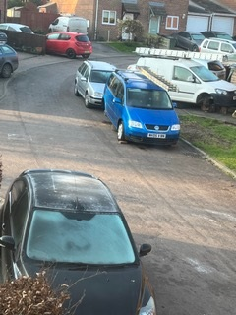 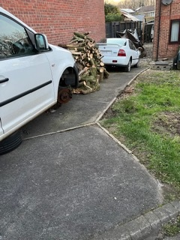

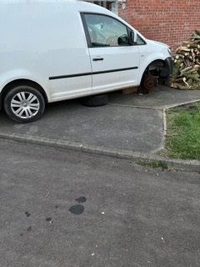 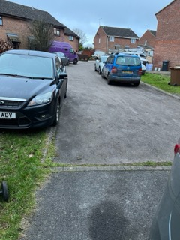

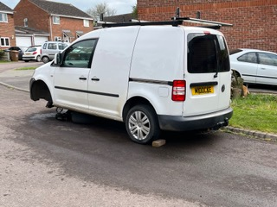 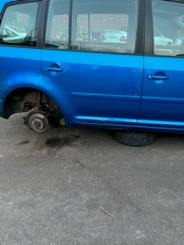

County Councillor Mr C Donnelly stated that he will take this issue up with Hampshire Highways to get a clear statement on who is responsible. Cllr Mr c Donnelley was given a copy of the report for reference.

**PARISH COUNCILLOR’S REPORTS.**

There were no issues raised.

**MEMBERS OF THE PUBLIC.**

There were no issues raised.

**CLOSE OF THE MEETING.**

The Chairman thanked everyone for coming and closed the meeting.

**DATE OF THE NEXT MEETING.**

4th of April 2023 at 7pm in the Grateley Village Hall.

**WEBSITE.**

[www.grateley.net](http://www.grateley.net)